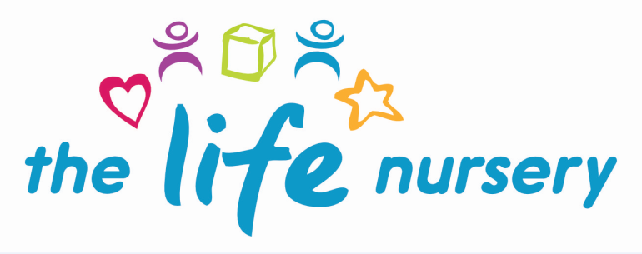

Key Person Policy

Nursery endeavour to value, respect and celebrate each individual child and family.

Our aim is to ensure children who attend The Life Nursery establish a firm bond with the staff and for them to work in partnership with parents/carers enabling a clear flow of information between the nursery and home environment.

The Key Person role is set out in the Safeguarding and Welfare Requirements of the Early Years Foundation Stage (2017). Each child must have a Key Person. These procedures set out a model for developing a Key Person approach that promotes effective and positive relationships for children.

In order to achieve this:-

- Each child is assigned their own key person after the initial settling in period.

- The Manager or Key Person will complete relevant forms with parents, including consent forms.

- The Manager or Key Person will explain The Life Nursery policies and procedures to parents with particular focus on policies such as Child Protection and Safeguarding and our responsibilities under the Prevent Duty.

- The Key Person will have links with other childminders/carers and nurseries involved with the child and co-ordinate the sharing of appropriate information about the child’s development with those people involved, through having a home link book.

- We encourage new children in the nursery to establish a bond with a key member of staff.

- Encourage different aspects of transition to enable the settling in process to be a positive experience for the child and their families.

- The key person is responsible for individually planning for their children considering the Early Years Foundation Stage (EYFS, 2017) document through adult led and child initiated activities.

- Each key person is responsible for observing, recording, evaluating and extending each child’s learning in all areas. These achievements are monitored and recorded in the child’s learning journey which is a shared document between home and nursery, including photographic evidence and creative work. Parents are encouraged to look at their child’s learning journey every half term and contribute to their child’s learning journey by recording written and photographic observations of their child at home.

- Parents are introduced to their key person and encouraged to approach them informally regarding any concerns, however can also approach the Manager if they should wish to do so.

- The Life Nursery is committed to identifying and responding to children who may have Special Educational Needs and Disabilities (SEND) in line with the SEND Code of Practice and the Children & Families Act 2014. https://assets.publishing.service.gov.uk/government/uploads/system/uploads/attachment_data/file/398815/SEND_Code_of_Practice_January_2015.pdf

- If through observational evidence a child fails to be making progress, external support will be informed and signed parental consent gained.

Reviewed March 2019

Policy read and agreed by:

Name | Date

