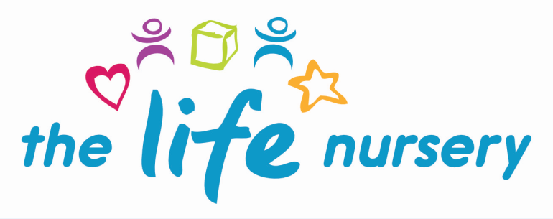

Healthy Snack Policy

Policy statement
The Life Nursery regard snack and meal times as an important part of the nursery day. Eating represents a social time for children and adults, helping children to learn about healthy eating, promoting independence and choice. The Life Nursery promote healthy eating using resources and materials from ‘HENRY’ (Health, Exercise, Nutrition for the Really Young). At snack times, The Life Nursery aim to provide nutritious food, which meets the children's individual dietary needs.

Procedures
The Life Nursery follow these procedures to promote healthy eating during snack and lunch time sessions.
- Before a child starts to attend the setting, The Life Nursery ask their parents about their dietary needs and preferences, including any allergies.
- The Life Nursery ask parents to record information about each child's dietary needs in the Registration Form and ‘All About Me’ booklet and ask parents to sign the form to signify that this is correct.
- The Life Nursery display information about individual children’s dietary needs are displayed in the kitchen to ensure staff, volunteers, students are fully informed about them.
- The Life Nursery regularly consult with parents to ensure records of their children's dietary needs – including any allergies - are up-to-date. Parents sign the updated record to signify that it is correct.
- The Life Nursery implement systems to ensure that children receive only food and drink that is consistent with their dietary needs and preferences, as well as their parents' wishes.
- The Life Nursery display the menu of snacks for parents to view on the ‘Parent Board’.
- The Life Nursery provide nutritious food for all meals and snacks, avoiding large quantities of saturated fat, sugar and salt and artificial additives, preservatives and colourings.
- The Life Nursery introduce foods from the diet of each of the children's cultural backgrounds, providing children with familiar foods and introducing them to new ones.
- The Life Nursery take care not to provide food containing nuts or nut products and especially vigilant where we have a child who has a known allergy to nuts.
- Through discussion with parents and research reading, The Life Nursery obtain information about the dietary rules of the religious groups to which children and their parents belong, and of vegetarians and vegans, as well as about food allergies. We take account of this information in the provision of food and drinks.
- The Life Nursery demonstrate sensitivity in providing for children's diets and allergies. The Life Nursery do not use a child's diet or allergy as a label for the child, or make a child feel singled out because of her/his diet or allergy.
- The Life Nursery will NOT provide children with grapes or raw carrot to avoid choking.
- The Life Nursery organise snack times so that they are social occasions in which children and adults participate.
- The Life Nursery use snack times to help children to develop independence through making choices, serving food and drink, feeding themselves and washing their own plate and cup.
- The Life Nursery provide children with utensils that are appropriate for their ages and stages of development and that take account of the eating practices in their cultures.
- The Life Nursery provide fresh drinking water bottles (with a picture of the child and their name) these are constantly available for the children. The Life Nursery inform the children about how to obtain the water and that they can ask for water at any time during the day.
- The Life Nursery inform parents who provide a packed lunch for their children about the storage facilities available in the nursery.
- In order to protect children with food allergies, The Life Nursery discourage children from sharing and swapping their food with one another.
- The Life Nursery provide semi-skimmed milk in such as on cereal and also as a drink which is supplied by Cool Milk. Each child is entitled to one third of a pint of milk per day.
- The Life Nursery work in partnership with parents and gain knowledge from health professionals in developing healthy eating practices within the nursery.
- The Life Nursery meets the fully requirements of the Safeguarding and Welfare requirements of the EYFS framework: Health.

Packed lunches
The Life Nursery cannot provide cooked meals and children are required to bring packed lunches, we:
- ensure perishable contents of packed lunches are refrigerated or parents are required to provide an ice pack to keep food cool;
- inform parents of The Life Nursery’s Snack policy on healthy eating;
- inform parents that we do not microwave cooked food brought from home due to the risk of food poisoning;
- encourage parents to provide sandwiches with a healthy filling, fruit, and milk based deserts, such as yoghurt or custard. The Life Nursery discourage fizzy and sugary drinks;
- discourage packed lunch contents that consist largely of crisps, processed foods, sweet drinks and sweet products such as cakes, chocolate or biscuits;
- do not allow children to eat nuts as part of their packed lunch due to the risk of an allergic reaction to the child or other children in the nursery;
- provide children bringing packed lunches with plates, cups and cutlery; and
- ensure that adults supervise and sit with children to eat their lunch so that the mealtime is a social occasion.

Legal framework
- Regulation (EC) 852/2004 of the European Parliament and of the Council on the Hygiene of Foodstuffs.

Further guidance
- Safer Food, Better Business (Food Standards Agency 2011)

This policy was devised by Louise Gray, Nursery Manager

Dated 1 November 2018

Signed…………………………………. Dated…………………………………..

Policy read by:

