The Life Nursery
Prospectus
2019 - 2020

102-104 Bierley House Avenue
Bierley
Bradford
BD4 6BU

Telephone: 01274 687588
Email: info@thelifenursery.co.uk
www.thelifenursery.co.uk

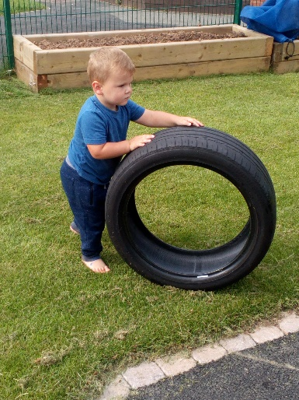
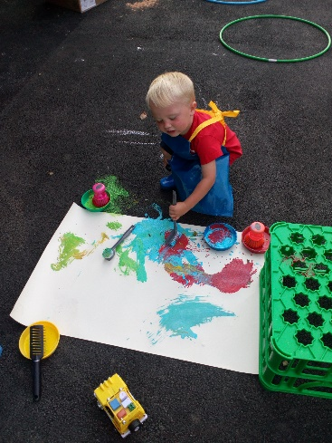

The Life Nursery History

In 2016, Bradford Council identified a shortage of high quality places for nursery education within BD4 and in particular, Bierley.

OURBD4 is a company that was established in 2016 to provide community childcare and family liaison to improve life chances, educational standards and employability within the BD4 area of Bradford.

The company was formed using expertise and community resources from two existing organisations – Bradford Academy and BD4 Community Trust.

Both organisations wanted to work together to create a unique company that could serve local children and families through making use of our experienced personnel skills from both the community and educational sector.

To enable the provision of independent yet supported childcare at nurseries within BD4, the company was formed with the support of the local authority.

In 2017, OURBD4 opened its first nursery – The Life Nursery - Bierley.

The Life Nursery is a brand-new purpose-built facility with capacity for 24 children at each session.

In October 2019 we had our first Ofsted Inspection and was awarded an ‘OUTSTANDING’ provider. Take a look by opening the link below:-

https://reports.ofsted.gov.uk/provider/16/EY547903

Staff

The Life nursery employs a high-quality team of Early Years Practitioners with qualifications ranging from NVQ Level 2 in Childcare and Education to Level 6, BA Degree in Childhood Studies with Early Years Professional Status. Our practitioners undertake regular training to ensure they have up-to-date knowledge and guidance and all have acquired full paediatric first aid and safeguarding training.

Louise Gray - Nursery Manager

BA in Childhood Studies with Early Years Professional Status
Designated Safeguarding Officer
Special Educational Needs Co-ordinator

Francesca Edwards – Deputy Manager
Level 3 - CACHE Diploma in Childcare and Education
Deputy Designated Safeguarding Officer
Behaviour Management Co-ordinator

Demi Gibson - Early Years Practitioner

Level 3 Diploma for the Children and Young People’s
Work Force

Iqrah Mahmood – Support Early Years Practitioner

Level 2 Certificate for Children and Young People’s Workforce

Saaiba Taliba – Childcare Apprentice

We maintain a high staff-child ratio, staff are highly qualified with all holding a full paediatric first aid certificate and attend annual refresher training. We have one special educational needs co-ordinator who has the responsibility of liaising with parents/carers and outside agencies in the event of any children requiring extra support based on their individual needs and abilities.

Staff attend regular training ensuring we can cater for individual children’s needs, this enables us to keep ourselves up to date with new legislation as well as extending our knowledge and expertise.

We provide placement opportunities for students and apprentices studying a childcare qualification.

Nursery Provision

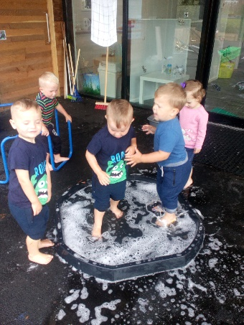
We believe children should be in a safe and stimulating environment, which is also fun. Learning needs to be enjoyable. We work to all OFSTED regulations and cover all the learning outcomes in the Early Years Foundation Stage (EYFS). We introduce the children to different cultures, festivals and religions, having taster days where the children are given the chance to taste different foods from countries around the world.
A splashing time.

Children have free flow access to play both indoors and out. The outdoor area is secure and enclosed for their safety, which is accessed in all weathers throughout the year, giving children the chance to experience the changing seasons. We have a mud kitchen; a large sand pit as well as numerous other resources for outdoors. Children are encouraged to help with planting and caring for all the vegetables and flowers in our vegetable garden.
Sweeping the puddles.

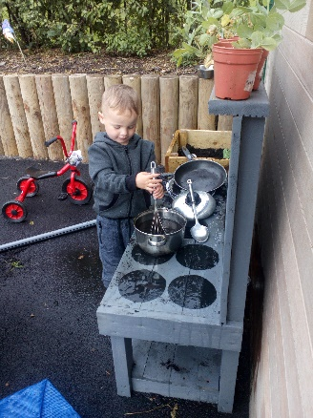
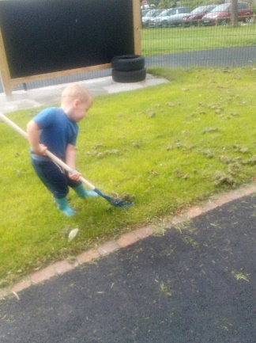
Mud Mud Glorious Mud.
Developing my muscles as I rake the grass.
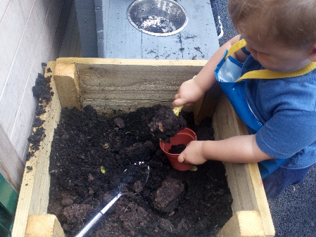
Planting our seeds.

The Nursery Sessions

The nursery offers 15 and 30 hour funded places for children aged between 2- 5 years. We are registered to take 24 children per session. All sessions are mixed age and ability groups allowing the children to learn from each other. We provide flexible session choices for parents.

Morning Session: 8.30 am -11.30 am
Lunch 11.30 am – 12.15 pm
Afternoon Session: 12.15 pm -3.15 pm

Fees

We also offer childcare places for parents who wish to pay for their place. Fees are as follows: -

Morning/afternoon Session £15 2-year-olds

Morning/afternoon Session £15 3 and 4-year-olds

Lunch time cover £3.50 2, 3 and 4-year-olds

Snack Times

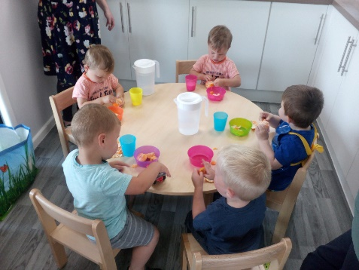
The nursery believes that snack time is just as important as any other activity in nursery, whereby children can use this time as a social occasion in sitting with their peers with the supervision of an adult. The nursery promotes independence and children are encouraged to pour their own drinks, make their own choices in self-selection of snack.
Chatting with my friends at snack time.

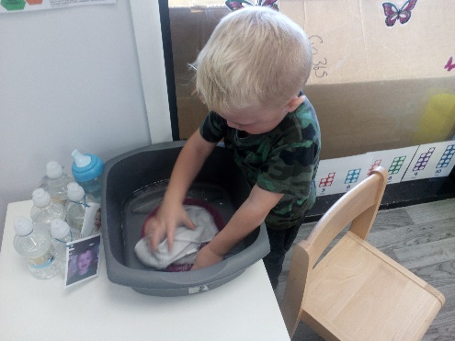
Children are encouraged to wash their own cup and plate after snack. All children are entitled to 1/3 pint of milk per day and we get our milk deliveries from a company called ‘Cool Milk’. Fresh drinking water is available for all children and accessible always. Only healthy snacks are provided.
I know how to wash up after snack.

Your child’s day
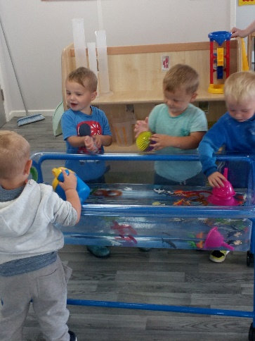
Chatting together as we play.
At the Life Nursery, we firmly believe that children learn through play. The ability to do this by interaction, involvement and fun ensures a child can access learning in a non-pressurised way and therefore develop their abilities in all areas of learning. For example, when playing with water your child is exploring sensory development such as warm or cold as well as investigating capacity, floating and sinking as well as developing the physical skills of filling and emptying containers.

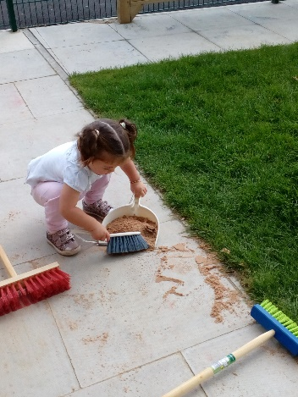
I can clean up when I spill things.

Children can also learn about risk and health and
safety due to clearing up of any spillages and
independence of putting on their own apron

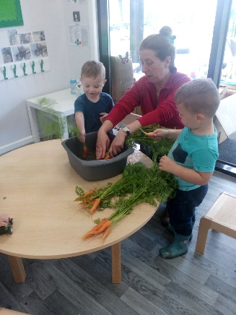
Cleaning the vegetables, we have grown, ready to eat.

Children develop their social and communication skills as they talk and play with others, sharing their thoughts and experiences. Daily, we provide a range of stimulating and challenging activities and resources following the children’s current interests as well as abilities.

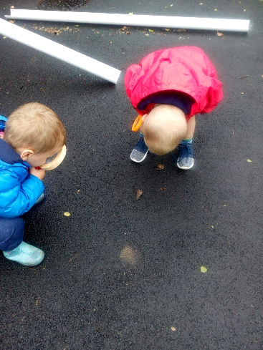

Look what we have found.

All areas of the nursery are equipped with resources frequently changed either by the staff or through children’s interests whilst playing enabling them the opportunity to enhance and extend their own play. Our environment encourages natural curiosity both indoors and out, through exploration, problem solving and investigation. All this and much more is provided through your child’s play. Free flow outdoor access enables the children to be more aware of the outside world, giving them the opportunities to experience the changing of the seasons, life cycles of plants and animals as well as taking care of the environment.

We display children’s work along with photos and observations so you can see what their current interests are as well as what they are capable of.

Newsletters are sent out half-termly to inform you of any important dates and activities happening at The Life Nursery. We value all contribution from parents and carers and pride ourselves in forming positive relationships with our parents and working in partnership in the interests of each child, sharing learning opportunities at home and nursery. We encourage home learning and regularly give parents ideas for them to do with their child at home.

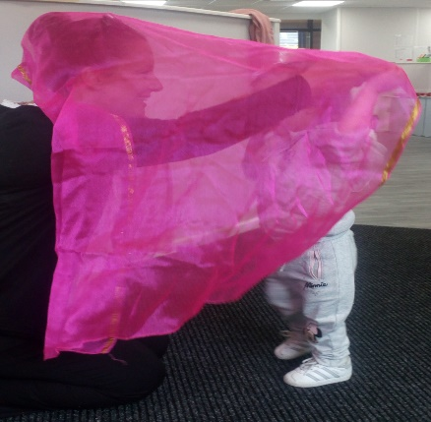
Building a relationship with my keyperson.
Each child is assigned their own keyperson. Their role is to build a bond both with the child and their family enabling parents and carers to feel comfortable should they need to discuss any worries or concerns they may have regarding their child and their time spent with us. All staff will observe and monitor your child’s progress, contributing to their learning journey with photos and written observations.

Curriculum, Planning and Assessment

The Early Years Foundation Stage (2017) curriculum is based around seven areas of learning and development. For children under two, we concentrate on three Prime Areas:
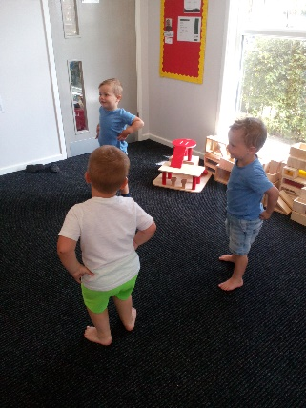
Music and movement time.

- Communication and Language
- Personal, Social and Emotional Development
- Physical Development

These areas cover the knowledge and skills required to form the foundations of formal learning. The Prime Areas develop through effective relationships and experiences, supporting learning in all other areas and remain fundamental throughout the EYFS.

The four Specific Areas of learning and development grow from the Prime areas and provide important opportunities for extending knowledge:

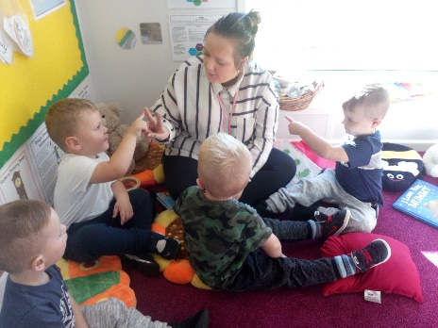
Learning to count whilst singing the 'Speckled Frogs' song.

- Literacy
- Mathematics
- Understanding the World
- Expressive arts and design

Children are continually observed and assessed to ensure they are developing. Should we discover that a child is not making progress in any of the above areas we will involve the nursery SENCO who will assist staff in putting a plan in place to ensure the child is being given the right opportunities to aid development. This may be adapting the way we offer resources, extra staff support or purchasing further resources. Should this have no or little impact on the child’s progress we will ask your permission to seek further support and guidance from outside agencies such as Early Years Support at Bradford Council or other professionals such as speech and language therapists.

Settling

We understand the importance of children settling; feeling safe and comfortable in a new environment. Therefore, we work with parents/carers to devise a settling programme that caters for their child’s individual needs. Our ‘All About Me booklet’ helps practitioners and parents share information such as likes, dislikes, feeding and sleeping routines; children’s interests and comfort strategies. We aim to make our nursery as homely as possible to promote comfort and security together with a sense of belonging and trust for each and every child and parent. You will be invited to visit with your child before their starting date. Starting with short visits building up to short sessions without you. If you feel your child would settle better with you staying with them, you are quite welcome to do this as we want you as parents/carers to feel happy too. The staff also offer home visits to our new starters to enable the child and families to meet each other and find out more about the nursery.

Parent Partnerships

At the Life Nursery we respect parents as their child’s first and most enduring care-givers and educators. From settling and day-to-day care to assessing and planning, we include and value parents’ contribution. We feel it is important for children to observe good relationships between parents and practitioners. We encourage parents and carers to complete observations at home which are included in their child’s learning journey and regular parental feedback opportunities. In addition, daily discussions are had upon dropping off and picking up your child from nursery. We have an ‘open door’ policy and parents are invited for regular reviews on their child’s progression with their child’s key person.

Complaints

Should you have any concerns these should be raised initially with your child’s key person. If the matter is not resolved or you would like to speak to the Manager, this will be arranged as quickly as possible.
If you are dissatisfied with any aspect of our service, you can contact Ofsted, the regulators of early years’ settings, at:
Applications, Regulatory and Contact (ARC) Team
Ofsted
Piccadilly Gate
Store Street
Manchester
M1 2WD
Tel: 0300 123 1231

If you would like further information about Ofsted, you can visit their website at www.ofsted.gov.uk/early-years-and-childcare

Safeguarding

All our practitioners, students and volunteers working at The Life Nursery have an enhanced DBS check and do not work unsupervised until these are completed. We are required to follow procedures as laid down by the Bradford Safeguarding Children Board, which includes sharing concerns that we may have with Social Services and/or the Police. Please inform us of any accidents or injuries your child has sustained outside of nursery. If a child receives an injury outside nursery, parents are asked to give an indication of the cause; the details are recorded on an Existing Injury Form, which you will be asked to sign. This is normally retained in your child’s confidential file, unless any necessary action needs to be taken, or help sought. Please read our full Safeguarding and Child Protection Policy.

Your Child’s Safety

To ensure your child’s safety whilst in our care, all external doors are locked and monitored by our staff. The outdoor area is enclosed with no access from outside – other than through our building. Each half-term, regular fire drills ensure staff and children are aware of the routine.
We operate a system whereby only named adults detailed on the admission form will be able to pick up. Your child will not be allowed to leave nursery with anyone who is not on the admission form.
Children will always have accidents and staff will fill out an accident form, no matter how small the incident and parents will be informed and asked to sign the form.

Flexible Childcare

Should you require any extra sessions, you can book your child a place. Payment is required prior to your child attending this session.

Medicines

Should your child require any medication whilst they are at nursery, you will need to complete a medication form and ensure this is signed to give permission. Medication must be given to a member of staff and not left in your child’s bag. Should your child become ill whilst at nursery, we will endeavour to contact you or one of your emergency contacts to come and collect them. If your child is ill, he/she should stay at home and please telephone us to let us know. In the event of diarrhoea and sickness, children are not allowed back to nursery until 48 hours after the last bout.

Clothing

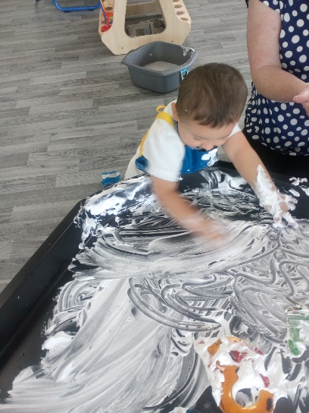
Messy Play

As all children have access to all areas such as water, messy and outdoor play (in all weathers), please provide your child with spare clothing which can be kept in their bag on their peg, in the event of any accidents.

Nursery Education Funding

The government provides funding for eligible 2,3 and 4 year olds. All eligible children can start nursery the term after their second or third birthday. It is the responsibility of the nursery to check eligibility before offering a child’s place. Alternatively, parents can do their own eligibility check and email or print off proof of eligibility – Bradford’s online 2-year-old checker.

If your child’s birthday is between 1 January and 31 March – their funded place would start from 1 April that year.
If your child’s birthday is between 1 April and 31 August – their funded place would start from 1 September that year.

If your child’s birthday is between 1 September and 31 December – their funded place would start from 1 January the following year.

Qualifying parents are also able to claim an additional 15 funded hours on top of the universal 15 funded hours. Parents can apply for the 30 hours funding through an online application which includes an eligibility check – Childcare Choices.

Once you successfully apply online, you will be given a code which you then present to us. We then use the eligibility checking system to check the code is valid.

For more information - www.childcarechoices.gov.uk

Late Collection

We understand that situations arise whereby you may be late to collect your child from nursery. Should this happen, please contact us as soon as possible. We consider the circumstances that lead to late pick up, however reserve the right to charge for persistent lateness (see Late Collection policy).

Learning through play…………

The staff would like to welcome you and your child to The Life Nursery and look forward to working in partnership in providing fun learning experiences for your child to progress in their early years.
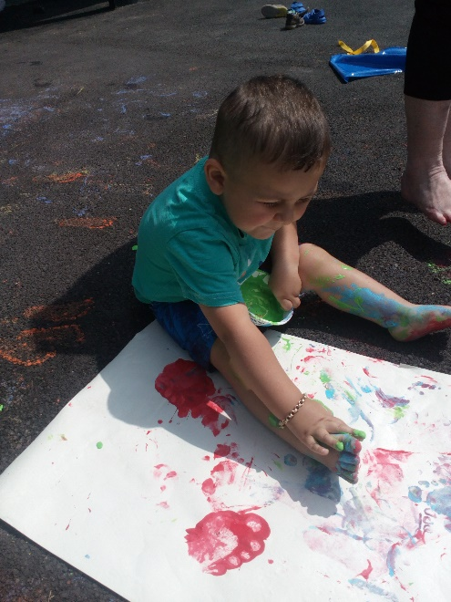
I like to feel the paint on my skin.

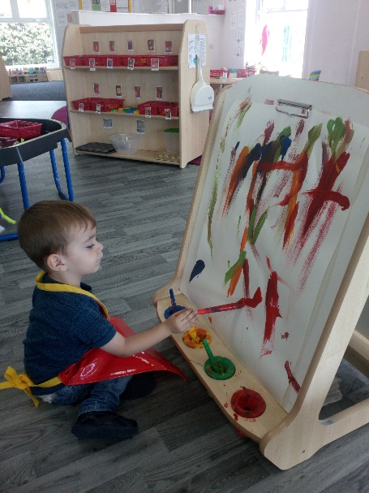
I am free to be creative
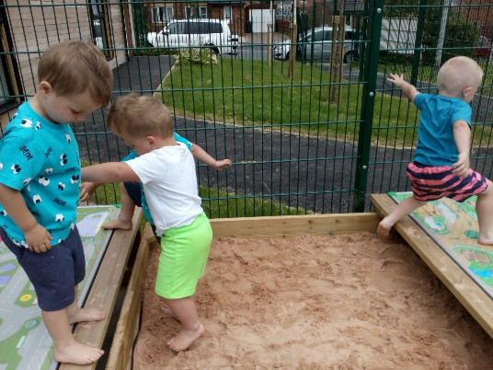
Sand between our toes.

