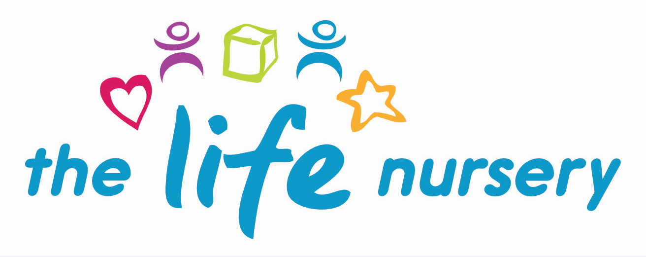

ACCIDENT AND INJURY POLICY

The Life Nursery follow the guidelines of the Reporting of Injuries, Diseases and Dangerous Occurrences Regulations (RIDDOR) for the reporting of accidents and incidents. Child protection matters or behavioural incidents between children are not regarded as incidents and there are separate procedures for this.

The purpose of this policy is to ensure that if an accident occurs at The Life Nursery appropriate action is taken and accurate information is recorded and communicated.
An accident is classed as an occurrence which has resulted in an injury to one or more persons.

Responsibilities:
The Nursery Manager will ensure that medical information and emergency contact numbers are kept up to date.

It is the responsibility of every member of staff to ensure that accidents and injuries are dealt with in a timely manner.

The Nursery Manager is responsible for ensuring that all staff members are paediatric first aid trained.

If a child comes to nursery with an injury, a member of staff should enquire as to how the injury occurred and ask parents/carers to fill in and sign an ‘existing injury record’. This will prevent other staff from mistaking injuries that happen at nursery with those that have happened elsewhere and may prevent a child suffering abuse outside the nursery. The child’s welfare is paramount.

Procedure:
- The accident forms must be kept securely and safely in the office.
- The accident forms must be accessible to staff and volunteers who all know how to complete them.
- A first aider will assess whether an injury can be dealt with in the nursery or if medical assistance is required.
- Any member of staff who administers first aid must write an accident report on an accident form and ensure that it is signed by the parents/carers of the child or children involved.
- If a child has a bumped head injury an accident report on an accident form must be filled in and signed by the parents/carer of the child, together with providing parents with a copy of the ‘bumped head’ form.
- Where a child refuses eg. a cold compress or staff to examine the injury and it is deemed to be minor, staff are to respect the child’s views and record that the child refused treatment on their individual accident report form.
- All members of staff have a responsibility to ensure that the Manager is informed when items from the first aid box are used. A system is in place to ensure that the first aid box is restocked on a regular basis.

Reporting Accidents and Incidents
- Ofsted is notified as soon as possible, but at least within 14 days of any instance which involve:-
- food poisoning, affecting two or more children
- a serious accident or injury to, or serious illness of, a child in our care and the action that The Life Nursery will take
- A death of a child in our care
- Local child protection agencies are informed of any serious accident or injury to a child, or the death of any child in our care and will act on any advice given by those agencies
- Any food poisoning affecting two or more children or adults in the nursery, is reported to the local environmental health department (01274 437766).
- The Life Nursery meets legal requirements in the respect of the safety of employees and parents/carers complying with RIDDOR. We report to the local authority.
- Any work related accidents leading to an injury to a child or member of staff for which they are taken directly to hospital for treatment.
- Any work related accidents leading to a specific injury to a member of staff, such as fractured bones, the loss of consciousness due to head injury, serious burns or amputation.
- Any work related accidents leading to an injury to a member of staff which results in them being unable to work for seven consecutive days or work related injuries need to be recorded on the staff accident report form.

Minor injuries: Accident Form
If an injury is minor and does not require medical assistance, the first aider should deal with it and write up an accident report as per above.

If the injury is minor but requires some medical assistance, the first aider will contact the parents/carers and ask them to collect their child. An accident report will be completed and sent with the parents/carers.

Serious Accidents and Injuries:
If the injury is serious and hospital treatment is required a member of staff should call an ambulance and the child’s emergency contact. The member of staff should accompany the child in the ambulance with the child’s registration form containing their medical information if the parent/carer is delayed or not available at the time.
They will remain with the child until a relative has arrived. In the event of this happening, ensuring correct ratios of children and staff, left in the nursery.

Recording Accidents:
All accidents and injuries, however minor, must be recorded on the child’s individual accident form.
The accident record should include the following:
- Name of person reporting accident
- Date and time of accident
- Where and what happened
- Exact part of body injured
- Treatment given (if any).
- Parent/carer signature

Accident Reporting Forms at The Life Nursery
- Accident forms – to be completed if a minor accident
- Bumped head forms – to be completed and a copy given to parents of bumped head accidents
- Existing injury forms – to be completed by parents if child has an injury when dropping off
- Incident forms – Incidents such as a child biting, nipping, hitting another child
- Child Accident Report form – used if medical assistance required
- Critical Incident Report form (to be completed within 14 days) – used if reporting serious accidents, illness, injury or death of a child
- Physical Intervention form – To be completed should a member of staff need to in an emergency restrain a child from causing injury to themselves or others
- Staff accident form – to be completed by staff should they have an accident at work

Reviewed by Louise Gray, Nursery Manager and Fran Edwards, Deputy Manager – September 2020

Policy read and agreed by:

Name | Date

