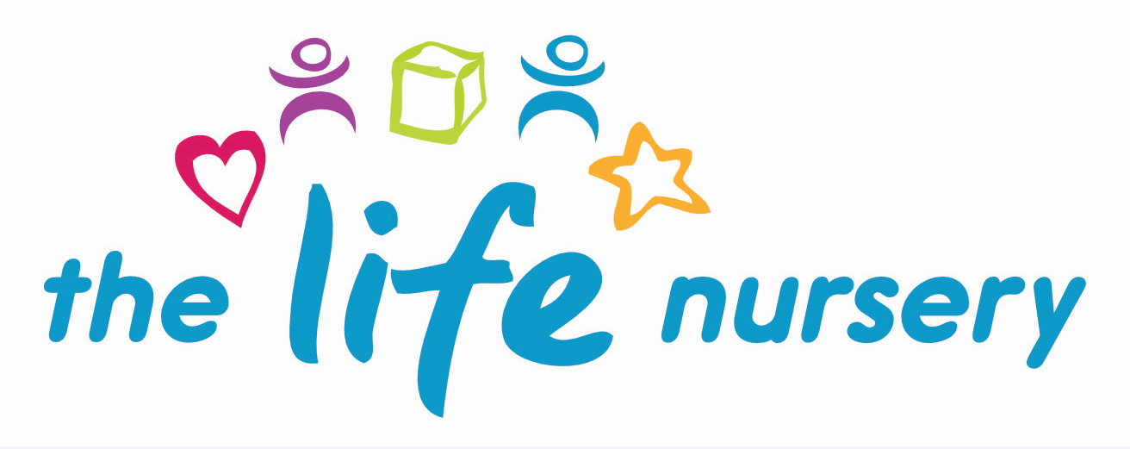

ADMISSION, FUNDING AND CHARGING POLICY

1. Purpose

At the Life Nursery, we are committed to being inclusive with regards to admissions. We strive to be a provider of funded childcare without it impacting the quality of our provision. This policy outlines our approach to nursery admissions, admissions criteria followed, and our plans for offering funded childcare in a sustainable and inclusive manner.

2. Legal Framework

This policy relates to sections 3.28 and 3.57 of the Statutory Framework for the Early Years Foundation Stage (2017).

3. Nursery Admissions

At the Life Nursery we care for children between the ages of two and four years of age, and the numbers and ages of children admitted to the nursery comply with the legal space requirements set out in the Statutory Framework for the Early Years Foundation Stage (EYFS). When considering admissions, we are mindful of staff: child ratios and the facilities available at the nursery. We aim to ensure that all sections of our community have access to the nursery through open, fair and clearly communicated procedures.

Places will be offered on a first-come, first-served basis if there are places available, but if there is a waiting list, the nursery will use the following admission criteria, length of time on waiting list, but each individual case will be looked at and considered dependent on the needs of the child and family.

Government funding for early education can be used for hours within normal morning or afternoon sessions. No charges are made for these sessions. If you wish your child to do their 15 hours over less days this is a possibility but the time between morning and afternoon session is chargeable at a rate of £3.50 to cover staffing costs. You would also need to provide your child with a suitable packed lunch. We also offer 30 hours funded places subject to receiving a 30 hour eligibility code from the parent/carer. As per above a child staying for both morning and afternoon sessions, £3.50 would need to be paid to cover the lunch time period.

We also accept fee paying places and these are chargeable at £15.00 per session for children aged between two, three and four year old. If staying all day, charged as above for lunch time period. All fees must be paid in advance of care.

We operate an inclusion and equality of opportunity/diversity policy and ensure that all children have access to nursery places and services irrespective of their gender, race, disability, religion, beliefs or sexual orientation of parents.

We strongly believe that all children should have fair and equal access to snacks and activities and we therefore do not charge any top-up fees for funded-only sessions.

Prior to a child attending nursery:

- We provide an ‘All About Me’ booklet, contract, registration form and parental agreement between parents/nursery and Bradford Council for the funded early education entitlement for two, three and four year olds, which must be filled in prior to your child starting nursery.

- You are welcome to visit the nursery prior to your child starting whenever is convenient to you, no appointment necessary.

- Our waiting list operates on a ‘time on list’ basis for each intake. Names, dates of birth and contact details are taken upon first enquiry.

- If the place is no longer required, the next child on the waiting list will be contacted according to ‘time on list’ basis.

- We follow our equal opportunities policy to ensure that we offer an environment inclusive to all.

- Although all efforts will be made to accommodate parental wishes for specific places, the final decision will be made by the Nursery Manager.

4. Attendance

Funded places are subject to certain criteria, please see attached ‘flowchart for non-attendance/reduced attendance guidance’.

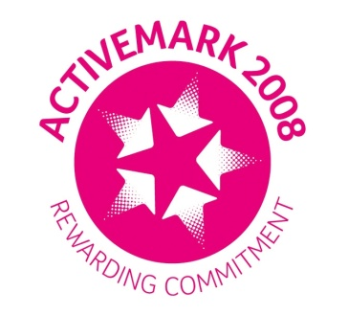
Reviewed by Louise Gray, Nursery Manager and Fran Edwards, Deputy Manager – September 2020

Policy read and agreed by:

Name | Date

