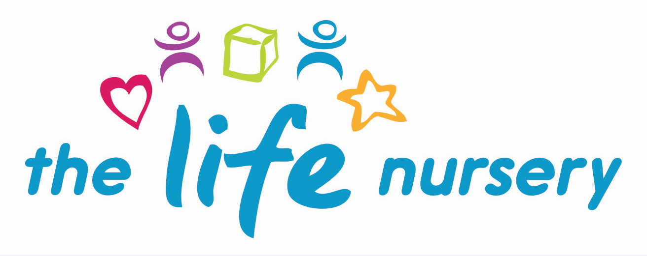

INDIVIDUAL LEARNING AND DEVELOPMENT POLICY
The Life Nursery is committed to providing excellent facilities for children to play, learn and develop following the Early Years Foundation Stage, around the areas of learning:

PRIME AREAS
- Personal Social and Emotional Development
- Physical Development
- Communication and Language

SPECIFIC AREAS
- Literacy
- Mathematics
- Understanding the World
- Expressive Arts and Design
The Life Nursery operates a key person system, each child will be allocated a key person on confirmation of their attendance at the nursery. There are opportunities during the children’s settling in sessions for parents and carers to discuss any learning requirements with their child’s key person.
The Nursery also provides the family with a form to fill in regarding their child’s interest’s likes and dislikes as this will enable their key person to plan learning activities around the children’s interests to encourage them to continue to be motivated and eager to play. Children have plenty of opportunities for self-initiated and adult led learning experiences both indoors and outdoors, using ‘In the Moment’ planning and following individual children’s interests.
Assessment:
All practitioners are involved in observing children on a daily basis. Spontaneous observations (photographs and written narrative) made while engaging alongside children in their play capture significant moments of children’s learning. These, together with more formal planned observations, are used by practitioners to support their developing knowledge of individual children and their abilities, needs, interests, play schemas and learning styles.

All children’s likes and dislikes are taken into account when planning for learning experiences; learning experiences are differentiated to include all children regardless of gender, ability, race, special educational needs and disabilities, age and language.

Progress check at age two:

Between the ages of two and three, practitioners must review each child’s progress and provide parents/carers with a short written summary of their child’s development in the prime areas. Practitioners understand that all children develop at different stages. If a child’s progress in any prime areas give cause for concern, practitioners must discuss this with the child’s parent and/or carers and agree how to support the child.

Practitioners must consider whether a child may have special educational needs or a disability which requires specialist support. The Manager/SENCO is able to advise staff and parents/carers if they do have concerns about any child’s development. Whilst working with families we are able to liaise with outside agencies to provide support for any children who may have a delay in an area of their development.
Early Years Foundation Stage – Learning Summary:

When children transfer to either another early years provider or school for the next stage of their learning and development, the key person must complete a Learning Summary. This details the progress the child has made across the EYFS to date and a written report detailing the way the child learns (characteristics of effective learning) is added.

Equal Opportunities:

All staff at The Life Nursery have a responsibility to maintain positive attitudes to diversity and ensure that inclusive practice is delivered in the early years’ environment.

All children, irrespective of gender, ability, ethnicity, culture, religion or social circumstances have the opportunity to experience a stimulating environment with challenges and opportunities for learning and development within The Life Nursery based on individual interests.

Intimate Care:

At The Life Nursery, we aim to uphold all children’s rights to privacy and dignity. We recognise we have the responsibility to safeguard not only children who may be in need of intimate care but also to safeguard the adults caring for them (see Personal Care and Toileting policy, Nappy Changing Policy)

Special Educational Needs:

The Early Years Foundation Stage recognises that all children are unique and that they develop at varying rates. However, there are some children who require additional support and resources to access the EYFS framework. Children identified as having specific additional educational needs and disabilities will have an Individual Support Plan written for them in consultation with parents to ensure that their needs are met.

Reviewed by Louise Gray, Nursery Manager and Fran Edwards, Deputy Manager – September 2020

Policy read and agreed by:

Name | Date

