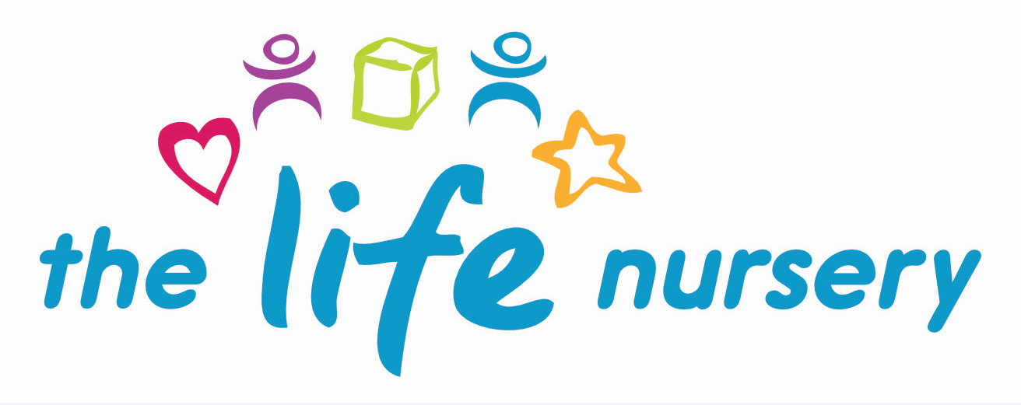

Social Media Policy

- Overview
This policy explains your responsibilities when you use social media, both on the nursery premises and in your own time.

It applies to all staff and to anyone else working at the Life Nursery, including volunteers and students. It does not form part of your contract of employment and can be amended at any time.

Your use of social media may, along with your wider use of nursery IT resources, be monitored to make sure you are complying with this policy. Whenever you use our IT resources and systems, you give us your consent to monitor your activities.

If you breach this policy you may face action under our disciplinary procedure. We may require you to remove any social media content that in itself breaches this policy and may invoke the disciplinary procedure if you fail to do so. In addition, you could face legal proceedings if comments you post about the Life Nursery or named individuals are found to have harmed their reputation.

- What is social media
We define social media as websites and applications that allow users to create and share content and/or take part in online networking. The most popular sites include the following:-

- Facebook
- Snapchat
- Twitter
- LinkedIn
- YouTube
- Google+
- Instagram
- Pinterest
- Flickr
- Tumblr
- Reddit

This policy also covers personal blogs, any posts you might make on other people’s blogs and to all online forums and noticeboards.

- Using social media at work
You must not use Life Nursery IT resources to access social media unless you need to do so as part of your job. You also must not use your own IT equipment – your personal phone, for example – to access social media during working hours unless during breaks and lunch times.

You must not post personal content on any Life Nursery social media account you are authorised to use. These accounts belong to us, and your access will be stopped if you abuse this policy in any way. If you leave the Life Nursery your access will also be stopped and we will ask for your user names and passwords. We may also ask for them at any other time and in either case you must supply them on request.

- Your responsibilities when using social media
Always identify yourself and make it clear your opinions are your own and you are not speaking on the Life Nursery’s behalf. You might consider doing this in a disclaimer. Use a personal email address, not your Life Nursery email address and do not create a social media account that could be mistaken for a corporate account we have set up, or could set up.

It is your duty to protect the Life Nursery’s interests and you must not publish anything that could directly or indirectly damage these or compromise our reputation. You must never speak on the Life Nursery’s behalf on social media unless authorised to do so and you must always make sure anything you do post is accurate and lawful. Always get your colleagues’ permission before posting images of them or any of their personal details.

You must take personal responsibility for your social media content. If you can be identified as working for the Life Nursery, you must make sure your profiles and anything you post, are congruent with how we expect you to present yourself to business associates and colleagues. Be mindful that even if you do not name us as your employer, people who know you and where you work may still make an unwelcome association with the Life Nursery. If you are in any doubt about what is and is not acceptable, please talk to your Manager.

You must always show respect to others when using social media. You must never criticise the Life Nursery, our children, parents, suppliers, outside agencies, business associates, your colleagues or anybody else you come into contact with professionally. Our other policies give guidance on the type of behaviour we consider unacceptable in the Life Nursery and we expect you to maintain the same high standards when using social media. Specifically, we will not tolerate any of the following:-

- Abusive or threatening language
- Sexual explicit language
- Unlawful or disrespectful comments
- False or misleading statements
- Impersonating your colleagues or third parties
- Inciting somebody to commit a crime

You are obliged to respect the Life Nursery confidentiality at all times and not to use social media to comment on sensitive matters, including – but not restricted to the following:-
- Our intellectual property
- Our trade secrets
- Our current or future performance
- Any information intended for internal use only
- Anything else that is not already in the public domain

We also insist that you never use our logo, trademark or other corporate artwork in anything you post or as part of any of your social media profiles.

You must remain aware at all times of the public nature of social media. Even content posted on a restricted forum can quickly be shared across other social media and you must assume that anything you publish anywhere will sooner or later reach the public domain. When you share content posted by others, remember that you may be seen as giving tacit approval to opinions that could bring the Life Nursery into disrepute.

You must never air grievances about the Life Nursery or any of its activities on social media. You should use our internal process if you want to make a complaint, raising it first with your Manager. If the issue remains unresolved, you must then following the formal grievance procedure.

It is acknowledged that some staff may have genuine friendships and social contact with parents of children outside of the professional setting of the Life Nursery. Staff in these situations should be more conscious of their social media security settings and also the content they are sharing.

Staff should be aware that the Life Nursery reserves the right to monitor or inspect email, internet access or any social media account used for work purposes. The Life Nursery considers that valid reasons for checking internet usage include concerns that there has been a breach of this policy, the Life Nursery ‘Child Protection and Safeguarding policy’ or any other nursery policy where evidence of that breach may be found within the email or social media account. The nursery also reserves the right to perform random checks on electronic communication to ensure they are being used appropriately and to ensure the safeguarding of our children.

Under no circumstances should staff use any form of social media to discuss the day to day activities of children.

- Other social media guidance
Always respect copyright and always check whether or not a third party’s content is protected before you reuse or re-post it.

The contact details of any business contacts you make while working for the Life Nursery belong to us and must remain confidential. When you leave the Life Nursery, you must give us this data and delete any copies you have, including any you have added to your social media accounts

You should contact your Manager if you find anything posted to a social media site that breaches this policy or otherwise brings the Life Nursery into disrepute.

Ensure that you familiarize yourself with the Life Nursery’s policies with regards to safeguarding and child protection.

Reviewed by Louise Gray, Nursery Manager and Fran Edwards – September 2020

Policy read and agreed by:

Name | Date

