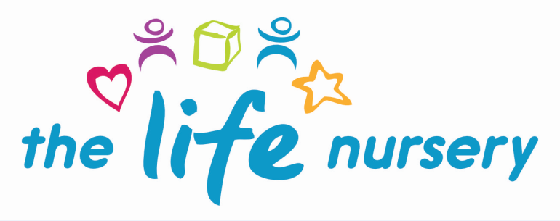

Privacy Notice

The Life Nursery will collect certain information about you and your child in order to comply with the requirements of the Early Years Foundation Stage (EYFS) and to maintain accounts and records, support your child’s teaching and learning, monitor and report on your child’s progress, assess the quality of our provision and to access funding for your child.

The Life Nursery is registered with the information Commisioner’s Officer (ICO) under the provisions of the General Data Protection Regulation 2018. The Life Nursery takes its responsibilities under the Act very seriously. This notice provides details of how The Life Nursery collects and uses information about you.

The Life Nursery handles your information in accordance with the General Data Protection Regulation 2018.

We acquire this information on a strictly need to know basis and is kept securely and confidentially. Where information is to be shared this will be done in an appropriate and secure manner.

What information we collect from you?
The Life Nursery collects some or all of the following information about you and your child for the purposes of early years funding entitlement.

Data
Personal information of you and your child as set out in the admission and parent agreement forms:-
- Name
- Date of birth
- Address
- Gender
- Ethnicity
- Special educational needs
- Number of entitlement of hours your child is accessing
- Details of other provider/s your child has attended including start date and end date
- Contact details
- National insurance number
- HMRC 30 hour eligibility code
- Eligibility for Early Years Pupil Premium
- Eligibility for Disability Access Fund

Who uses your information?
Bradford Council use your personal data in relation to the funding entitlement for 2, 3 and 4 year olds. We will not give information about you to anyone outside the nursery without your consent unless the law and our rules allow us to.

How is this information used?
- Confirming eligibility of children accessing funding entitlements, Disability Access Fund and Early Years Pupil Premium
- To calculate the amount of funding to be paid to The Life Nursery
- For Bradford Council to carry out financial audits of The Life Nursery
- Bradford Council carry out statutory functions to ensure sufficient funded entitlements are available. Statistics are used, but in a way that your child cannot be identified

The Life Nursery will ensure there is no abuse of personal data as we have the following controls, safeguards and limitations in place in regard to the use of and the sharing of your information:
- Information will not be used for any purpose other than those stated in this notice
- The information will be held and, when appropriate and necessary, shared securely in accordance with our policies and relevant legislation

The information can only be held and used with your consent. Due to some information having to be recorded as outlined in the Early Years Foundation Stage statutory guidance, withdrawing consent at any time will only be relevant to certain information not all, by informing Louise Nixon, Nursery Manager.

The Life Nursery will retain personal information/data for a certain period of time (see attached) and this will be securely destroyed once the time period has lapsed.

The Life Nursery requires you to consent to opting into agreeing to our ‘Privacy Notice’ which includes us processing, sharing and storing your personal information in the following ways:-

- Sharing your information with Ofsted, outside agencies if necessary
- Photos of your child to be included in learning journeys
- Information stored securely and locked away
- Consent for photos of your child on facebook
- Information/photos on laptop is password protected and on encrypted memory stick
- Ipads/tablets will be password protected and remain on nursery premises
- If staff take your child’s learning journey home to complete, these will be stored securely and not left in car
- Staff will seek permission from Manager before taking any work home
- Staff will sign out and sign in documents taken home
- Emails containing information about your child will be sent securely to other professionals using Galaxkey, which is a data protection product that protects email, documents and any data using access control and an encryption platform

I, ………………………………………………………………………….., parent/carer of ……………………………………. consent to The Life Nursery collecting, storing and using my personal data and opt-in to agreeing to this Privacy Notice

Signed………………………………………………………………….

Dated…………………………………………………………………..

Reviewed by Louise Gray, Nursery Manager and Fran Edwards, Deputy Manager – September 2020

