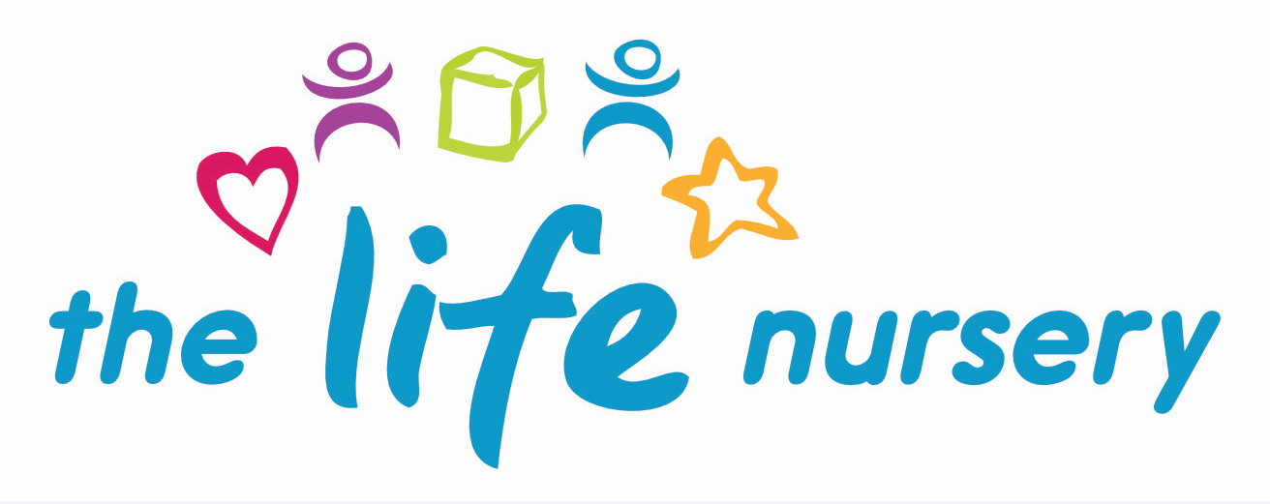

Sun Cream Policy

During the summer months, the sun rays can be particularly harmful to children’s delicate skin. As your child’s health and well being is extremely important to us, the aim of our policy is to help us protect them.

- All children have access to outdoor play at all times and we will continue to offer this, however, we will provide places of shade for your child to seek shelter from the sun.

- Parents will be advised to provide a named sun hat and children will be reminded to put these on before playing out.

- We recommend sun cream is applied to your child at home before coming into nursery.

- With parents’ permission, staff will assist your child with further applications if required, however, should you wish for this to happen you will need to provide a bottle of sun cream, clearly labelled with your child’s name on it. Staff will wear disposable gloves to apply.

- Water will be available at all times.

Please note: from time to time children can still be burnt by the sun even though we will ensure the above precautions are taken. In the unlikely event this should happen, The Life Nursery will not be held accountable for this.

Parent Consent

I give permission for nursery staff to apply sun cream to my child and I will provide a bottle of sun cream clearly labelled with my child’s name.

Name of Child: | Dated:
Name of Parent: | Signature of Parent:

Reviewed by Louise Gray, Nursery Manager and Fran Edwards, Deputy Manager – September 2020

Policy read and agreed by:

Name | Date

