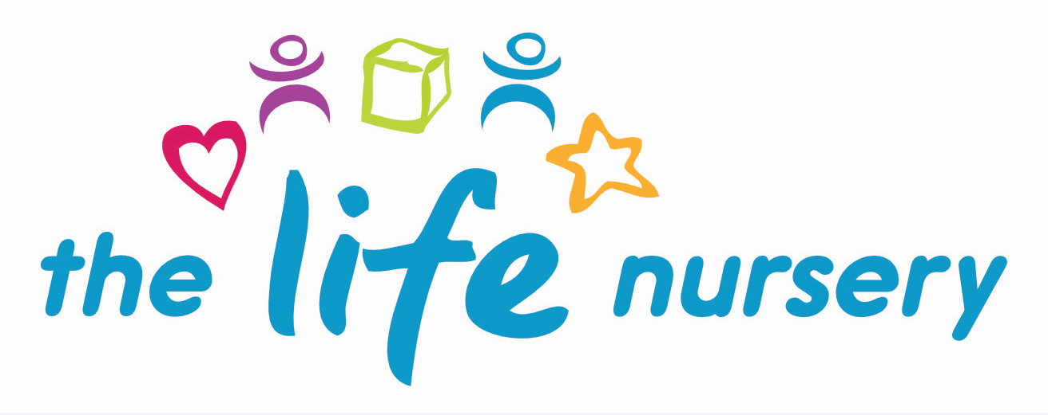

Inclusion Policy
The Life Nursery believe that the Early Years Foundation Stage Framework (EYFS) should be relevant to the individual needs of children. We aim to provide an inclusive education that gives all children access to a broad, balanced and stimulating environment, in which challenges and motivates them. The Life Nursery supports all children in raising their standards of achievement by setting high but attainable expectations.
We believe that all children should be equally valued. We strive to eliminate prejudice and discrimination, and to develop an environment where all children can flourish and feel safe.
The Life Nursery is committed to inclusion. Part of the nursery’s planning for improvement is to develop cultures, policies and practices that include all learners. We endeavour to achieve a sense of community and belonging and to offer new opportunities to children who may have experienced previous difficulties.
This does not mean that we will treat all children in the same way, but that we will respond to children in ways which take account of their varied life experiences and needs.
We believe that educational inclusion is about equal opportunities for all children, whatever their age, gender, ethnicity, disabilities, abilities, attainment and background.
This policy describes the way we meet the needs of children who experience barriers to their learning, which may relate to sensory or physical impairment, learning difficulties or emotional or social development, or may relate to factors in their environment, including the learning environment they experience in nursery.
We recognise that children learn at different rates and that there are many factors that can affect children not making progress which include:-
- disability
- behaviour
- English as an additional language
At The Life Nursery we aim to identify these needs as they arise and provide learning opportunities, focusing on individual needs and abilities, making adaptations if required in the nursery environment, which enable every child to achieve to his or her full potential.
Reviewed by Louise Gray, Nursery Manager and Fran Edwards, Deputy Manager – September 2020

Policy read and agreed by:

Name | Date

