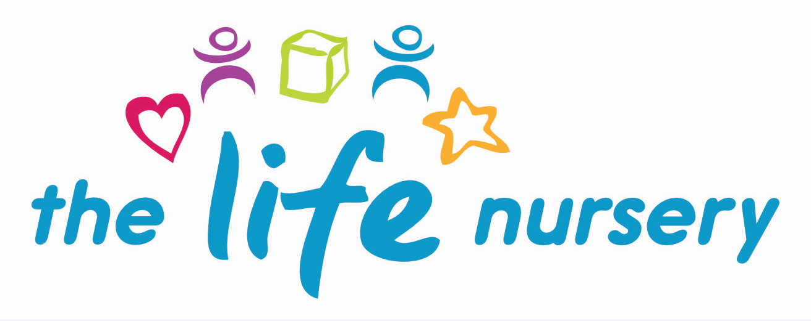

The Life Nursery - Equality of Opportunity/Diversity

The Life Nursery works in accordance with all relevant legislation including the Equality Act 2010 and the SEND 0-25 Code of Practice 2014. Staff at this nursery believe in promoting equal opportunities for everyone and value diversity in children, parents, carers, staff, visitors and all others we come into contact with.
We believe that all children have an entitlement to equal access to a broad balanced, relevant and differentiated curriculum. Staff strive to ensure that all children develop self-confidence and high esteem whilst we recognise and valuing differences between themselves and others.
The diversity of individuals and communities is valued and respected. No person including children, families or staff members are discriminated against.
The member of staff with responsibility for Equal Opportunities and Diversity is Louise Gray, Nursery Manager.
It is this member of staff’s responsibility to review, monitor and evaluate the effectiveness of our inclusive practice.
However, it is the responsibility of all staff to understand and promote equal opportunities through:

- Attending suitable training.

- Encouraging children to recognise their own unique qualities and the characteristics they share with other children.

- Working with families to ensure that individual information is gained for each child about such things as family customs and beliefs, home language, dietary requirements etc.

- Monitoring the curriculum and use of resources to ensure a broad and balanced curriculum that reflects our culturally diverse society and which is suitable for both active and more passive children.

- Promoting an anti-bias curriculum to actively challenge any negative feelings towards and stereotyping of others. This will be partly through using dolls, puppets and books to tell stories which help children to question their own feelings and views and to promote a sense of justice and fairness.

- Challenging negative comments from both children and adults.

- Providing a range of equipment which reflects a diverse society such as dual language books, home corner equipment which reflects a range of home cultures, stories which reflect the diversity of our society, small world equipment etc.

- Celebrating a wide range of cultural festivals using appropriate teaching materials.

- Writing notices in a variety of community languages.

- All children, irrespective of ethnicity, culture or religion, home language, family background, learning difficulties or disabilities, gender or ability will have the opportunity to experience a challenging and enjoyable programme of learning and development.

Reviewed by Louise Gray, Nursery Manager and Fran Edwards – September 2020
Policy read and agreed by:

Name | Date

