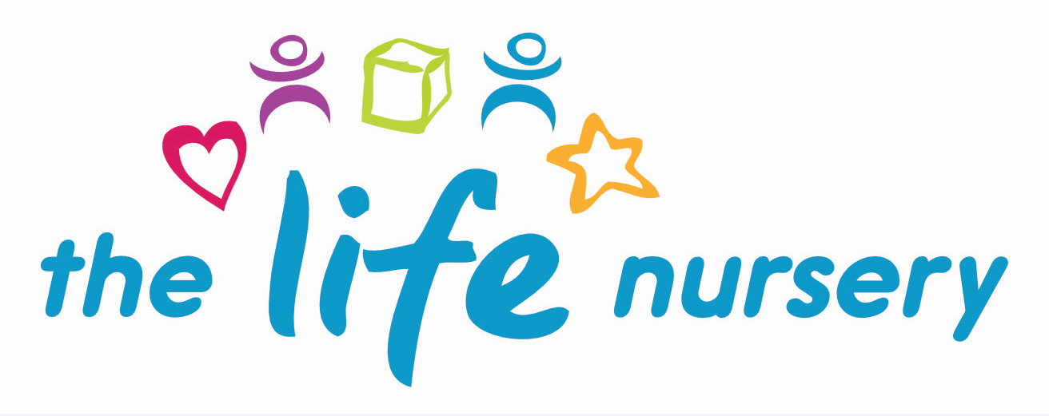

SMOKING, VAPING, DRINKING AND DRUGS POLICY

The Life Nursery complies with the health and safety regulations and the Safeguarding and Welfare Requirements of the Early Years Foundation Stage (2017) in making The Life Nursery a no-smoking environment – both indoors and outdoors.

It applies to staff, parents/carers, visitors and contractors entering the nursery building.

Procedures
- No smoking signs are displayed prominently.
- Staff who do smoke, do not so during working hours, unless on a scheduled break and off the premises.
- E-cigarettes are not permitted to be used on the premises.
- Smoking is not permitted in any vehicle belonging to the nursery.
- Staff will not be permitted to work in the nursery under the influence of drink or drugs.
- Staff are made aware that failure to adhere to this policy and procedure may result in disciplinary action.
- It is a criminal offence for employees to smoke in ‘smoke free areas’.
- Staff must inform the Manager if they believe any medication may affect their ability to care for children. If this is the case, they should seek medical advice and only work directly with children if the advice is that the medication is unlikely to impair their ability to look after children.
- If staff are concerned about releasing a child to a parent/carer whom they believe to be under the influence of drink or drugs, they must seek advice from the Manager.

The welfare of the child is paramount.

Reviewed by Louise Gray, Nursery Manager and Fran Edwards, Deputy Manager – September 2020

Policy read and agreed by:

Name | Date

