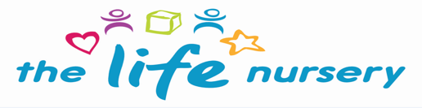

COSHH POLICY

COSHH is the law that requires employers to control substances that are hazardous to health. You can prevent or reduce staff’s exposure to hazardous substances by adhering to the following:-

- Finding out what the health hazards are
- Deciding how to prevent harm to health (see attached risk assessment)
- Providing control measures to reduce harm to health
- Making sure they are used appropriately and as per the label instructions
- Keeping all control measures in good working order
- Providing information, instruction and appropriate training for staff and any others
- Providing monitoring in appropriate cases
- Planning for any emergency
- Providing and wearing appropriate PPE (Personal Protective Equipment)

Many businesses use substances or products that are mixtures of substances. These could cause harm to staff and others.

Sometimes substances are easily recognised as harmful. Common substances such as paint, bleach or dust from natural materials can also be harmful.

COSHH covers
Substances that are hazardous to health. Substances can take many forms and include:-

- Chemicals
- Products containing chemicals
- Fumes
- Dusts
- Vapours
- Mists
- Gases and asphyxiating gases
- Biological agents (germs). If the packaging has any of the hazard symbols then it is classed as a hazardous substance
- Germs that cause diseases such as legionnaires disease

COSHH does not cover

- Lead
- Asbestos or
- Radioactive substances

Any substances that fall under COSHH regulations are kept in a locked cupboard in the kitchen to which children have no access. Staff are trained in the control of these cleaning products and ensure gloves and PPE are worn when in use. Substances such as bleach are not used when children are in the building. Other cleaning substances such as antibacterial spray are used when children are away from the area eg wipe tables after snack

All staff during the induction process complete online Health & Safety Training – Level 2.

The Life Nursery will only use cleaning products from the supermarket please see risk assessment attached.

In addition to chemicals, all body fluids are to be treated as substances hazardous to health and should be carefully dealt with using protective gloves and materials that can be safely disposed of.

Legislation
Health & Safety Executive (HSE)

This policy was reviewed by Louise Gray, Nursery Manager – September 2023

