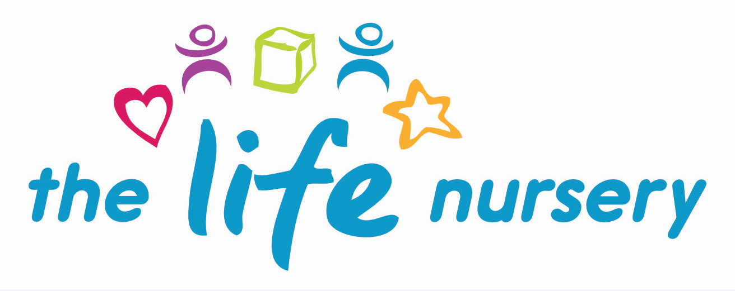

FOOD HYGIENE & PREPARATION POLICY

Statement of Intent

The Life Nursery prepare healthy and nutritious mid-morning and mid-afternoon snacks for children and supervise children who bring a packed lunch for dinner. The staff at The Life Nursery will ensure fresh drinking water and milk is accessible throughout the day. A variety of ‘cooking’ activities will be part of the nursery curriculum too.

The Life Nursery maintain the highest possible food hygiene standards with regard to the purchase, storage, preparation and serving of snacks and baking activities.

The Life Nursery understand the principles of Hazard Analysis and Critical Control Point (HACCP) as it applies to the nursery. This is set out in Safer Food, Better Business (Food Standards Agency) which is displayed in the kitchen for staff. The basis for this is risk assessment of the purchase, storage, preparation and serving of food to prevent growth of bacteria and food contamination.
- All staff follow the guidelines of Safer Food, Better Business
- All our staff who are involved in the preparation and handling of food have received training in food hygiene (Level 2)
- The person responsible for food preparation and serving carries out daily opening and closing checks on the kitchen to ensure standards are met consistently (Safer Food, Better Business)
- The fridge and freezer have thermometers to check temperature
- Food is stored at correct temperatures and is checked to ensure it is in-date and not subject to contamination by pests, rodents or mould
- Packed lunches are stored in a cool place and unrefrigerated food is served to children within 4 hours of preparation at home
- Food preparation areas are cleaned before and after use
- There are separate facilities for hand-washing and for washing up
- All surfaces are clean and non-porous
- All utensils, crockery etc are clean and stored appropriately
- Waste food is disposed of daily
- Cleaning materials and other dangerous materials are stored out of children’s reach
- Children do not have unsupervised access to the kitchen and the door remains securely locked
- All cupboards have child safety locks fitted
- When children take part in baking activities they are supervised at all times; understand the importance of hand-washing and simple hygiene rules and kept away from hot surfaces and hot water. Children do not have access to electrical equipment such as blenders etc.
- Children are encouraged to wash up their own bowls, plates and cups and these are washed by an adult afterwards

Reporting of Food Poisoning
Not all cases of sickness or diarrhoea are as a result of food poisoning and not all cases are reportable.
- Should a child be diagnosed by a GP or hospital to be suffering from food poisoning and where it seems possible that the source of outbreak is within The Life Nursery, the Manager will contact the Environmental Health Department to report the outbreak and will comply with any investigation
- The Life Nursery will notify Ofsted as soon as reasonably practicable of any confirmed cases of food poisoning affecting two or more children looked after on the premises and always within 14 days of the incident

Legal Framework
Regulation (EC) 852/2004 of the European Parliament and of the Council on the Hygiene of Foodstuffs

Further Guidance
Safer Food Better Business (Food Standards Agency 2011)

This policy was reviewed by Louise Gray, Nursery Manager and Fran Edwards, Deputy Manager – September 2023

Policy read and agreed by:

Name | Date

