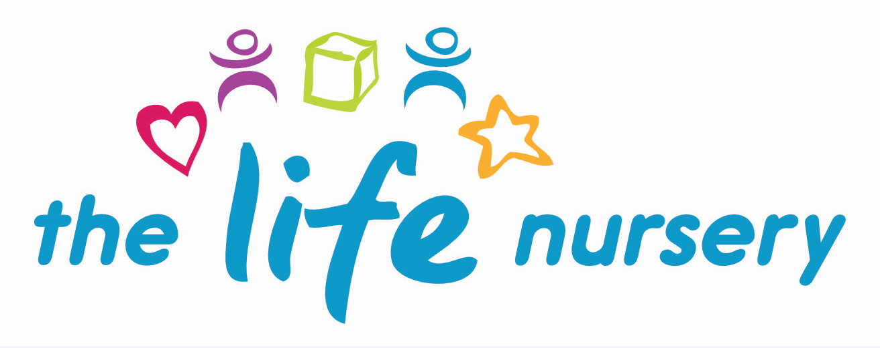

CODE OF CONDUCT FOR STAFF, VOLUNTEERS AND PARENTS POLICY

Introduction
At the Life Nursery we value our parents and understand the importance of a good working relationship in order to support the learning and development of every child and to prepare children for learning and development.
Purpose
The purpose of this policy is to provide all parents, carers and visitors to our nursery about the expected conduct, in order that we can flourish, progress and achieve in an atmosphere of mutual understanding.
Roles and Responsibilities
Staff have the responsibility to observe procedures to ensure the health and safety of parents, carers, work colleagues and themselves at all times. Reporting all occurrences of violence, aggressive/threatening behaviour and serious verbal abuse and near misses to the Manager and then the Board of Directors.
The Manager has the responsibility to take appropriate action in the event of violent, aggressive or threatening behaviour happening in the nursery to ensure its reoccurrence is prevented as much as reasonably practical and notify the Board of Directors.
Parents, carers and visitors have the responsibility to conduct themselves appropriately in line with this policy behaving in a reasonable manner at all times.
Principles
All members of the nursery community have the right to expect that their nursery is a safe place in which they can work, develop and learn. There is no place for violence, threatening behaviour, verbal or physical abuse or intimidation or harassment in the nursery.
Managing Children’s Behaviour
EYFS (2024) (3.60) ‘Providers must not give or threaten corporal punishment or any punishment which could negatively affect a child's well-being. Providers must take reasonable steps to ensure that corporal punishment is not given by anyone who is caring for or is in regular contact with a child, or by anyone living or working in the premises where care is provided. Any early years provider who does not meet these requirements commits an offence. A person will not be considered to have used corporal punishment (and therefore will not have committed an offence), if physical intervention42 was taken to avert immediate danger of personal injury to any person (including the child) or to manage a child’s behaviour if absolutely necessary’.

Expectations (next page)………..
Expectations
The Life Nursery expects parents, carers and visitors to:-
- Respect the caring ethos of the Life Nursery
- Understand that both nursery staff and parents need to work in partnership for the benefit of their children
- Demonstrate that all members of the nursery community should be treated with respect and therefore set a good example in their own speech and behaviour
- Correct their own child’s behaviour appropriately whilst on the nursery premises, especially where it could lead to conflict, aggressive behaviour or unsafe behaviour
Unreasonable Behaviour
In order to provide a safe nursery environment the nursery will not tolerate staff, parents, carers and visitors exhibiting the following:-
- Disruptive behaviour which interferes or threatens to interfere with the day to day running of the nursery or any other area of the nursery.
- Using loud and/or offensive language, swearing, cursing, using irrelevant or disrespectful language or displaying bad temper.
- Threatening to do harm to a member of the nursery staff, visitors, fellow parent/carer or child, regardless of whether or not the behaviour constitutes a criminal offence.
- The use of physical aggression towards another adult or child. This includes physical punishment or verbal abuse against your own child on nursery premises.
- Damaging or destroying nursery property or the property of another person.
- Abusive or threatening emails or text/voicemail/phone messages or other written communication to staff, visitors, fellow parents/carers or children.
- Offensive or derogatory comments regarding the nursery or any of the children, parents and staff at the nursery on Facebook or other social sites.
- Smoking and consumption of alcohol or drugs or being under the influence of alcohol or other drugs whilst on the nursery premises is not permitted.
- Dogs being brought onto the nursery premises is not permitted, apart from guide dogs.
Communication
Any concerns you may have about the nursery must be made through the appropriate channels by speaking to the Nursery Manager.
Procedures and Actions
Should any of the above behaviour occur, the Life Nursery may take possible action to deal with it. Where possible the nursery will resolve or diffuse violent/aggressive situations through discussion with the individual/s involved.
The Board of Directors may feel it necessary to issue a warning letter to the individual stating that repeats of such behaviour may lead to not being allowed on the nursery premises.
Where conflict cannot be resolved or diffused or there is the possibility of imminent physical harm towards an individual or nursery property, the nursery reserves the right to call the local police station to intervene or in cases of extreme emergency, by dialling 999 or to call the appropriate authorities.
Smoking, Vaping, Drinking and Drugs
The Life Nursery complies with the health and safety regulations and the Safeguarding and Welfare Requirements of the Early Years Foundation Stage (2024) in ensuring the nursery is a non-smoking environment – both indoors and outdoors.

It applies to ALL staff, parents, carers, visitors and contractors entering the nursery building and premises.

Procedures
- No smoking signs are displayed prominently.
- Staff who do smoke, do not so during working hours, unless on a scheduled break and off the premises.
- E-cigarettes are not permitted to be used on the premises.
- Staff will not be permitted to work in the nursery under the influence of drink or drugs.
- Staff are made aware that failure to adhere to this policy and procedure may result in disciplinary action.
- It is a criminal offence for employees to smoke in ‘smoke free areas’.
- Staff must inform the Manager if they believe any medication may affect their ability to care for children. If this is the case, they should seek medical advice and only work directly with children if the advice is that the medication is unlikely to impair their ability to look after children.
- If staff are concerned about releasing a child to a parent/carer whom they believe to be under the influence of drink or drugs, they must seek advice from the Manager.

The Life Nursery Dress Code/Rules

Due to the nature of working with children, Nursery Staff require a slightly more relaxed dress code to adhere to; however a smart level of dress is expected from all staff members at all times.
Jewellery may be worn, however this is worn entirely at the staff’s own risk and The Life Nursery will not be held responsible for any damage or injury.
The below is a guide to expectations.
OurBD4 Directors maintain the right to discuss anything that is or is not on this policy that they think constitutes inappropriate work wear, jewellery, hair or nails.
- Smart dress  - Black smart flat, full shoes/boots/ pumps  - Thick leggings can be worn under a tunic or dress  - Tops worn over leggings or tights to be at a suitable length  - Natural hair colour  - Visible piercings (small stud earrings are acceptable  - Nails MUST be short and smooth to allow safe physical interactions and physical interventions, including, where required, personal care or behavioural support and food preparation  - This guidance applies equally to natural nails and nail extensions/overlays, they MUST be short  - Tattoos and body art must be covered if possible  - Piercings are a personal choice, but at work, no facial or tongue jewellery should be worn.  - Jewellery should be kept to a minimum and is always worn at the individual’s own risk.  - Make-up must be natural and discreet | - Jeggings (including coloured)  - Denim (including coloured)  - Spaghetti straps/ strapless tops – no visible bra straps  - Overly exposed skin  - Trainers/Crocs  - Extreme hair styles including unnatural hair colours eg bright colours  - Extreme nails - length or design  - Open-toe shoes or open-toe sandals, heeled shoes  - Tattoos to be covered where possible  - Long earrings, necklaces, chains, etc. MUST NOT be worn. Care must be taken to ensure it does not cause a health and safety hazard and that jewellery cannot injure a child unintentionally.  - No chewing gum allowed to be consumed whilst working with children.

Reviewed January 2024 by Louise Gray, Nursery Manager and Fran Edwards, Deputy Manager

Policy read and agreed by:

Name | Date

