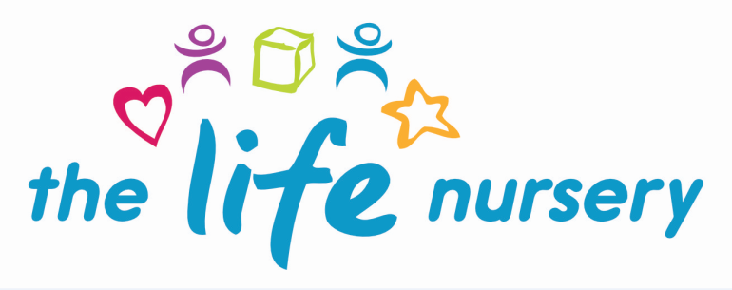

Key Person Policy

Nursery endeavour to value, respect and celebrate each individual child and family.

Our aim is to ensure children who attend The Life Nursery establish a firm bond with the staff and for them to work in partnership with parents/carers enabling a clear flow of information between the nursery and home environment.

The Key Person role is set out in the Safeguarding and Welfare Requirements of the Early Years Foundation Stage (2023) - “Each child must be assigned a Key Person”. These procedures set out a model for developing a Key Person approach that promotes effective and positive relationships for children.

In order to achieve this:-

- Each child is assigned their own key person after the initial settling in period.

- The Life Nursery policies and procedures are available on the nursery website and also in the nursery for parents and are encouraged to read these, with particular focus on policies such as Child Protection and Safeguarding and our responsibilities under the Prevent Duty.

- The Key Person will have links with other childminders/carers and nurseries involved with the child and co-ordinate the sharing of appropriate information about the child’s development with those people involved, through having a home link book.

- We also encourage children to establish bonds with all members of staff.

- Encourage different aspects of transition to enable the settling in process to be a positive experience for the child and their families (See Settling In Policy).

- The key person is responsible for individually planning for their children considering the Early Years Foundation Stage (EYFS, 2023) framework, through adult and child initiated activities and also parental involvement.

- Each key person is responsible for observing, recording, evaluating and extending each child’s learning in all areas. These achievements are monitored and recorded in the child’s learning journey which is a shared document between home and nursery, including photographic evidence and creative work. Parents are encouraged to look at their child’s learning journey every half term and contribute to their child’s learning journey by recording written and photographic observations of their child at home.

- Parents are introduced to their key person and encouraged to approach them informally regarding any concerns, however can also approach the Manager if they should wish to do so.

- The Life Nursery is committed to identifying and responding to children who may have Special Educational Needs and Disabilities (SEND) in line with the SEND Code of Practice and the Children & Families Act 2014.

- If through observational evidence a child fails to be making progress and needs additional support, the key person will speak with parents and support will be put in place and external support will be sought if needed. Parental signed consent will be given prior to any sharing of information with regards to this.

Reviewed Louise Gray, Nursery Manager and Fran Edwards, Deputy Manager – September 2023

Policy read and agreed by:

Name | Date

