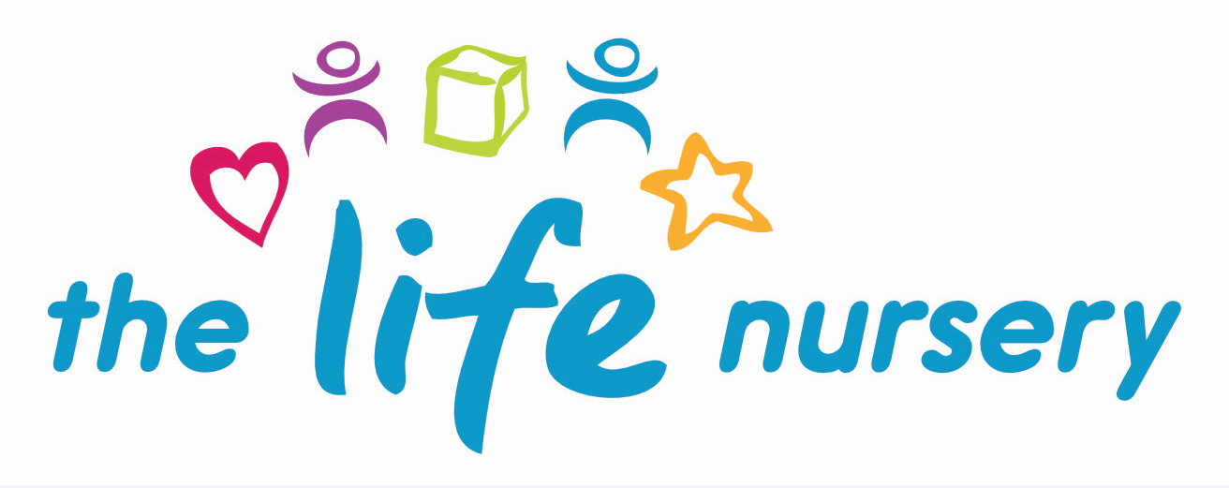
Special Educational Needs and Disabilities (SEND) and Inclusion Policy
The Life Nursery works in accordance with all relevant legislation including the Equality Act 2010 and the Special Educational Needs and Disability Code of Practice: 0 – 25 Years (2015) and the Early Years: Guide to the 0-25 SEND Code of Practice (2014).

“Providers are required to have arrangements in place to identify and support children with SEN or disabilities and to promote equality of opportunity for children in their care”.

“Providers must have arrangements in place to support children with SEN or disabilities. These arrangements should include a clear approach to identifying and responding to SEN”.

“All settings should adopt a graduated approach with four stages of action: assess, plan, do and review”.
‘Special Educational Needs and Disability Code of Practice: 0-25 Years (2015)’

Definition of Special Educational Needs

Children have special educational needs if they have a learning difficulty which calls for special educational provision to be made for them.
Children have a learning difficulty if they:
- have a significantly greater difficulty in learning than the majority of children of the same age; or
- have a disability which prevents or hinders them from making use of educational facilities of a kind generally provided for children of the same age in school

‘Special Educational Needs and Disability Code of Practice: 0-25 Years (2015)’

Aims
Staff at the nursery believe in promoting equal opportunities for everyone and value diversity in children, parents, carers, staff, visitors and all others we come into contact with. The diversity of individuals and communities is valued and respected.
We aim to provide an inclusive education that gives all children access to a broad, balanced and stimulating environment, in which challenges and motivates them. The Life Nursery supports all children in raising their standards of achievement by setting high but attainable expectations to ensure all children develop self-confidence and high esteem whilst we recognise and value differences between themselves and others.
We believe that all children should be equally valued. We strive to eliminate prejudice and discrimination, and to develop an environment where all children can flourish and feel safe.
The member of staff with overall responsibility for Equality and Inclusion is Louise Gray, Nursery Manager and Kirsty Beck, Early Years Practitioner.
It is this member of staff’s responsibility to review, monitor and evaluate the effectiveness of our inclusive practice.
However, it is the responsibility of all staff to understand and promote equal opportunities through:
- Attending suitable training.
- Encouraging children to recognise their own unique qualities and the characteristics they share with other children.
- Working with families to ensure that individual information is gained for each child about such things as family customs and beliefs, home language, dietary requirements etc.
- Monitoring the curriculum and use of resources to ensure a broad and balanced curriculum that reflects our culturally diverse society and which is suitable for both active and more passive children.
- Promoting an anti-bias curriculum to actively challenge any negative feelings towards and stereotyping of others. This will be partly through using dolls, puppets and books to tell stories which help children to question their own feelings and views and to promote a sense of justice and fairness.
- Challenging negative comments from both children and adults.
- Providing a range of equipment which reflects a diverse society such as dual language books, home corner equipment which reflects a range of home cultures, stories which reflect the diversity of our society, small world equipment etc.
- Celebrating a wide range of cultural festivals using appropriate teaching materials.
- Writing notices in a variety of community languages.
- All children, irrespective of ethnicity, culture or religion, home language, family background, learning difficulties or disabilities, gender or ability will have the opportunity to experience a challenging and enjoyable programme of learning and development.
Inclusion
The EYFS (Introduction) states….. “equality of opportunity and anti-discriminatory practice, ensuring that every child is included and supported”. EYFS (2024)
The Equality Act 2010 requires “settings to make 'reasonable adjustments' including the provision of auxiliary aids and services for disabled children”.

The Life Nursery adhere to the above by:-
- Promoting positive non-stereotyping images and diverse ethnic and cultural groups and people with disabilities or special educational needs
- To promote self-esteem and confidence in children and teach them to value and respect their own and other children’s contributions.
- To identify and recognise barriers to learning and participation that may be experienced by individual children and work with parents/carers and other agencies to respond to these as they arise.
- To provide a high quality programme of play and learning activities that is age and stage appropriate, stimulating, challenging, enjoyable and safe learning environment.
- To listen and respond to a child’s own wishes expressed with regards to their play and learning.

Special Educational Needs and Disabilities

The SENCOs for The Life Nursery are Louise Gray, Manager and Kirsty Beck, Early Years Practitioner.

The Life Nursery provide an environment in which all children with special educational needs and disabilities (SEND) are supported to reach their full potential.

- The Life Nursery provide parents/carers with an ‘All About Me’ booklet, providing an opportunity to give information on their child and their individual needs, prior to starting nursery.
- The Life Nursery have in place a clear approach for identifying early, responding to, and meeting children’s special educational needs.
- The Life Nursery support and involve parents (and where relevant children), actively listening to, and acting on their wishes and concerns.
- The Life Nursery work in partnership with the local authority and other external agencies to ensure the best outcomes for children with special educational needs and their families.
- The Life Nursery regularly monitor and review their policy, practice and provision and, if necessary, make adjustments.

Procedures
- The SENCO works closely with other staff and has the responsibility for supporting children with special educational needs and for co-ordinating the nursery to ensure it is accessible for every child.
- The Life Nursery have regard for the Special Educational Needs and Disabilities Code of Practice 0-25 years and the Disabilities Discrimination Act 1995 and the Equality Act 2010 and the Children and Families Act 2014.
- The Life Nursery ensures that the provision for children with SEN is accessible and it is the responsibility of all members of staff in the nursery to do this.
- The Life Nursery ensures that their inclusive Admissions Policy ensures equality of access and opportunity.
- The Life Nursery provide a broad, balanced and differentiated range of activities for all children.
- The Life Nursery applies for appropriate SEN support and funding upon early identification of children with SEN.
- The Life Nursery use the graduated approach system (assess, plan, do and review) applied in increasing detail and frequency to ensure that children make progress.
- The Life Nursery ensure that parents are involved at all stages of the assessment, planning, provision and review of their children's progress.
- The Life Nursery where appropriate, take into account children’s views and wishes in decisions being made about them, relevant to their level of understanding.
- The Life Nursery provide parents with information on local sources of early support and advice e.g. Early Help, Bierley Community Centre, our Access and Inclusion Officer.
- The Life Nursery work in partnership with other professionals and external agencies to help improve outcomes for children with SEN.
- The Life Nursery have systems in place for referring children for further assessment e.g. Early Help Plan and Education, Health and Care (EHC) assessment.
- We ensure the effectiveness of our SEN/disabilities provision by collecting information from a range of sources: IDLP’S reviews, staff and management meetings, parental and external agencies views inspections and complaints. This information is collated evaluated and reviewed on a regular basis.
- We recognise these children constantly working beyond their next step of learning and IDLP’S are written accordingly to support them.
- We use a system of planning, implementing, monitoring and evaluating and reviewing individual development learning plans (IDLP’S) for children with SEN/disabilities

Further guidance

- Early Years Foundation Stage Statutory Framework (2024)
- Working Together to Safeguard Children (2023)
- Equality Act (2010)
- SEND Code of Practice (2015)
- The role of the Early Years Special Educational Needs Coordinator

Reviewed by Louise Gray, Nursery Manager/Director and Fran Edwards, Deputy Manager – January 2024
Policy read and agreed by:

Name | Date

